SE 2228: Worksheet 4

09.04.2021

**Q1)**

In this lab, you are expected to implement a greedy algorithm to find a solution for the coin change problem. As previously explained, the coin change problem is based on finding the minimum number of coins that equals to the amount owed. An example is given in the figure below:

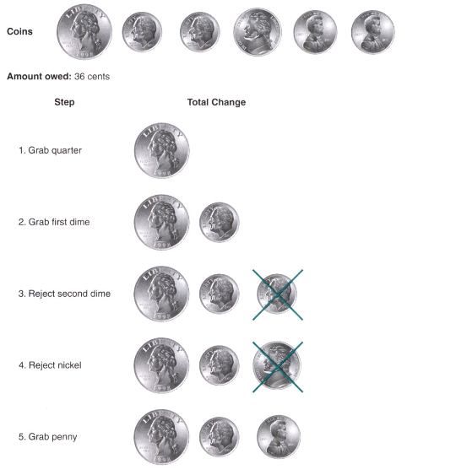

According to this strategy, implement your code by defining the coin values (amounts) that you have in which you can assume that you have an unlimited number of coins for each value. (the number of dimes: unlimited, the number quarters: unlimited, ….)

**Q2)**

In the first code, you had an unlimited number of coins. In this question, you will modify your code and your algorithm will also check whether you have enough coins to give it back to the customer. (An example: If your algorithm tries to take quarter but if you don’t have one, then it should pass to the next greatest amount).